14th ICRED MEETING
March 2023
HOTEL BOOKING FORM

Please kindly complete your reservation form and return to Ms. Rany Lim
PLEASE MAIL OR FAX TO: sales.pp@angkorparadise.net / Fax: (+855) 78 760 690
Tel: (+855) 63 760 690 /
Address : National road No6, Phum Taphul, Sangkat Svay Dangkum, Siem Reap, Cambodia
1. PARTICIPANT INFORMATION
Title | Mr. |  |  |  |  | Mr.
 | Mrs. |  |  |  |  | Mrs.
 | Ms. |  |  |  |  | Ms.
Passport No.  (For Security Passes) |  |  | Country
First Name |  |  | Last Name
Organization
Phone |  |  | Including national & regional number (ex. +855-78- 760 690)
Email
Address
2. HOTEL RESERVATION
Check-in |  |  | Check-out
Number of Nights | ______ Night(s)
Sharing with | ※ I will share my room with this person
Flight Detailed | Arrival Flight____________ Time________________ |  |  | Airport pick up Yes No  Airport transfer Yes No  (air pot picks up and transfer will offer with complimentary)
Room Booking: I would like to reserve……………………………………
ANGKOR PARADISE HOTEL (HOTEL CONFERENC)  (Please tick your room type) |  |  |  | ANGKOR HOTEL (RECOMMENTED HOTEL)  (Please tick your room type)
Room Type | Single | Twin/Double |  | Room Type |  |  | Single | Twin/Double
Deluxe Room | USD45.00 | USD50.00 |  | Deluxe Room |  |  | USD38.00 | USD43.00
Executive Suite | USD150.00 | USD150.00 |  | Junior Suite Room |  |  | USD55.00 | USD55.00
We are pleased to extend a series of special benefits:

*Welcome drink and cold towels upon group arrival *In room amenities on arrival including water (replenished every day)
*Complimentary coffee/tea making facility *Complimentary use of the Swimming Pool
*Complimentary access to the steam room, sauna *Complimentary Buffet breakfast
*Complimentary used of internet (WIFI)
*Airport Pick up and Transfer

[Important Notices]
- All room rates will be charged in US Dollar and include breakfast, tax and service charge.
- Check-in Time: From 14:00 Check-out Time: By 12:00
- Request for early check-in and/or late checkout will be subjected to room availability and chargeable.

CANCELLATION POLICY
- If cancellation is made before 16 days: no charge
- If cancellation is less than 16-8 days before arrival date: 50% charge
- If cancellation is less than 7 days before arrival date: 70% charge
- If no-show or same day cancellation: 100% charge
* “No-show”: When guests do not check in without any notice in advance.
3. PAYMENT METHOD (Please indicate your preferred method of payment and payment details.)
 |  | I will guarantee the hotel reservation by credit card:
Payment Method |  | □ Credit Card □ Bank Transfer *Credit Card is highly recommended.  (If you wish to make payments by Bank Transfer, please contact our reservation via e-mail)
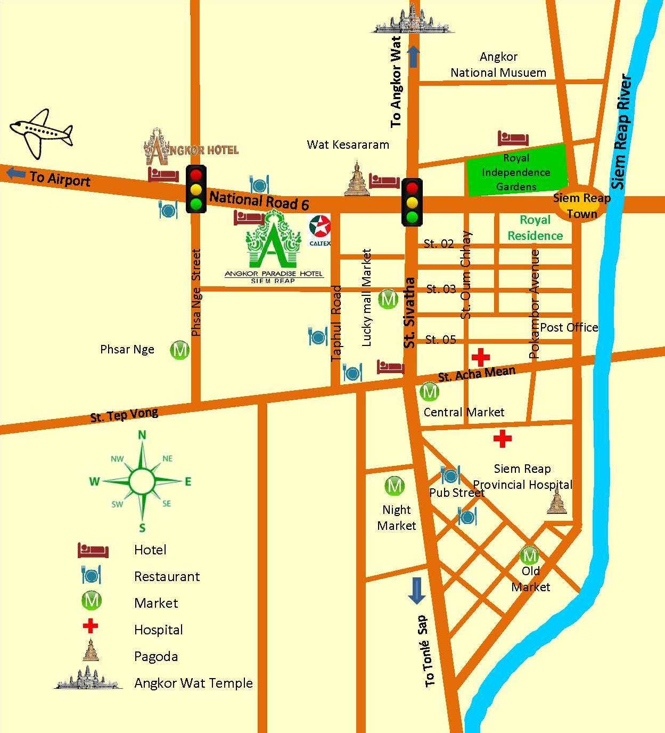  HOTEL MAP  Distance:  - Hotel to Airport: 7 km /10 mn  - Hotel to City Center: 1.5 km/5 mn  - Hotel to Angkor Wat : 7 km/10 mn  *Distance from Angkor Paradise Hotel to Sokha Hotel => 250m  *Distance from Angkor Hotel to Sokha Hotel => 500 m |  |  |  |  | 